Project 6 – Main App Explained
Table of Contents
Script – Main.py 2
Setup 2
Route 1: /health 3
Route 2: / and /info 4
Reading the Secret 4
Building the JSON response 5
Startup 6
Request Flow 6

Script – Main.py
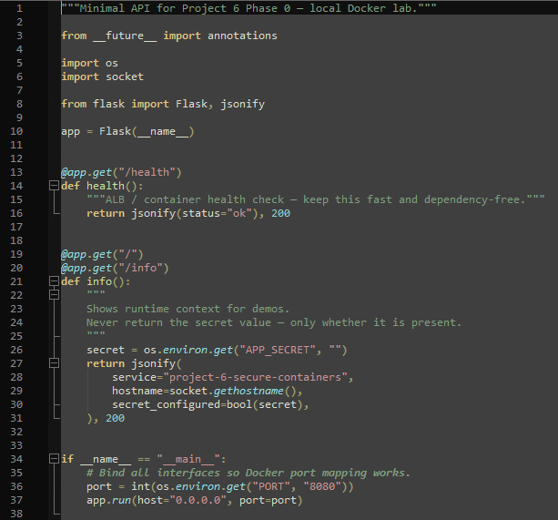

Setup
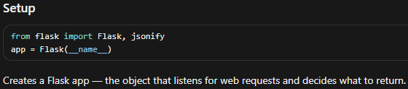

Route 1: /health
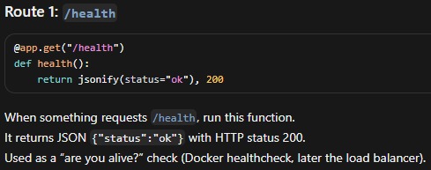
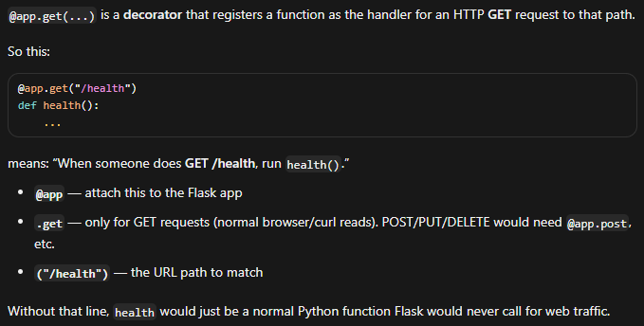

Route 2: / and /info
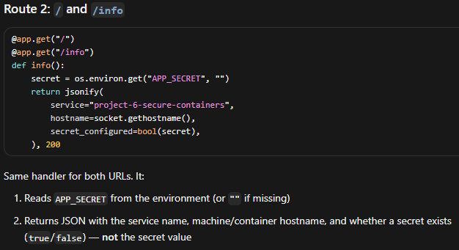
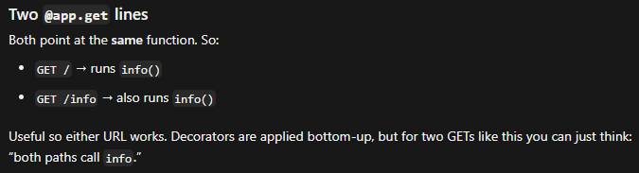

Reading the Secret
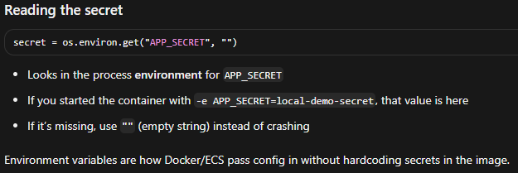

Building the JSON response
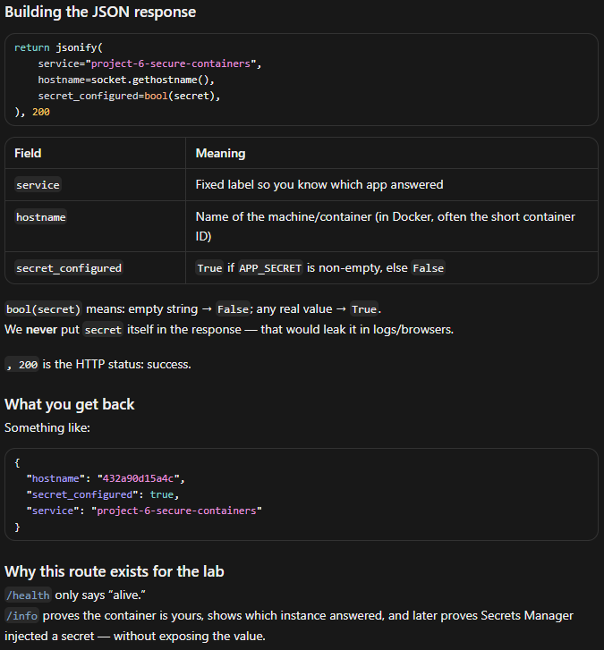

Startup
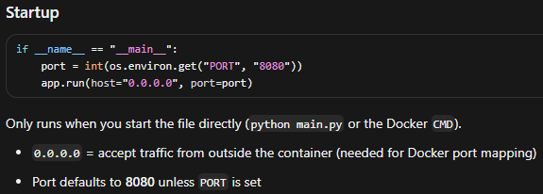

Request Flow
